

Programme | : | M.Tech Int Software Engineering | Semester | : | Fall 2026-2027
Course | : | Database Systems Lab | Code | : | IASWE206
Faculty | : | Dr. M. Premalatha | Slot | : | L31+L32

Date: 12-10-2026
Ex No: 9
PL/SQL Procedures, Functions, Triggers and Cursors

Note:
LMS Submission Format [Word File]
Regno, name
Course code, course title
Slot
Faculty Name
Question
SQL Query
Screenshot

Ex:
SQL> create table student_mp(regno varchar(4), sname char(10), mobno number(10), dob date);
Table created.

SQL> desc student_mp
Name Null? Type
----------------------------------------- -------- ----------
REGNO VARCHAR2(4)
SNAME CHAR(10)
MOBNO NUMBER(10)
DOB DATE
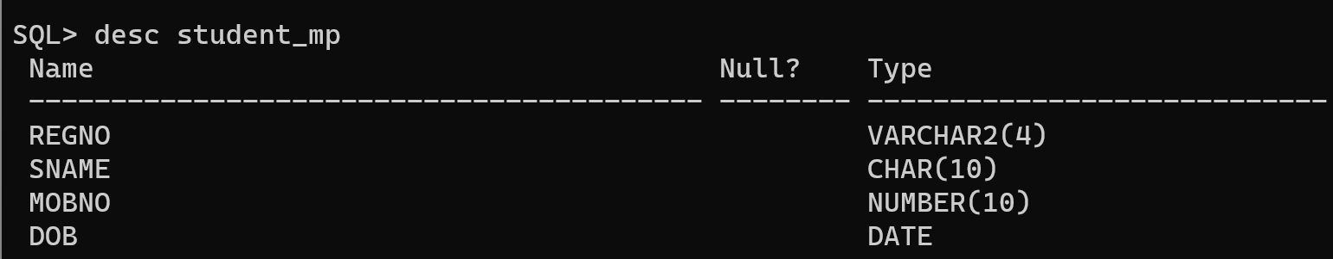

student(regno, sname, cgpa, school)
course(ccode, cname, credits)
faculty(empid, fname, designation, salary)
course_student(regno, ccode)
course_faculty(fid, ccode)

From the already created tables with key constraints of the above specified schema, write the SQL queries for the following:

- Add 0.5 cgpa to the student ‘ram’ [use procedure]
- Find the average salary of the ‘professors’ [use function]
- List the course name registered by the student ‘lal’ [use implicit cursor]
- List all the faculty names who receive salary more than the salary of ‘paul’ [use explicit cursor]
- Create a function to calculate the number of courses registered by a student.
- Create a procedure to display faculty members teaching a particular course.
- Write a before update trigger on the student table to ensure that the CGPA entered is between 0 and 10.
- Write a after update trigger on the faculty table to display the old and new salary whenever a faculty member's salary is updated.

